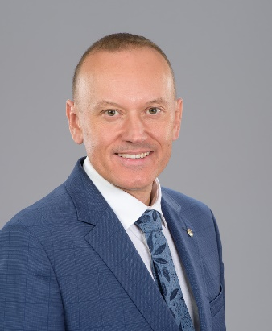
Prof. Pawel Wielgosz
General information: Professor in technology and engineering, Department of Geodesy, Faculty of Geoengineering, UWM in Olsztyn. Research on Global Navigation Satellite Systems (GNSS) application to precise positioning and navigation, ground deformation monitoring, remote sensing of the ionosphere and troposphere.
Research Career: 1997 master of sciences, 2002 doctor of philosophy, 2011 doctor of sciences (habilitation), 2019 full professor.
Employment and job titles: 2002–2012 assistant professor, 2012–2019 associate professor, 2019– full professor. 2012–2017 Vice-Dean for Research, 2015–2017 Director of the Institute of Geodesy, 2017–2020 Dean of the Faculty of Geoengineering, 2017– member of the University Senate, 2019– member of the scientific council of the civil engineering and transport discipline, 2020– Vice-Rector for international affairs.
Scientometric indicators: according to WoS: 47 articles with IF, 900 citations (730 excluding selfcitations), h-index = 19, https://orcid.org/0000-0002-5542-1481
Research projects: Principal investigator in 2 international projects (European Space Agency – ESA) and 5 national projects, investigator in 12 international (8 from ESA) and 7 national projects, supervisor in 2 PRELUDIUM projects. PI in 9 projects from the industry.
Coordination of courses, teaching activity: Lectures: Fundamental Geodetic Measurements, Satellite Measurement Techniques, Advanced Geodetic Data Processing, Current Research Problems in Geodesy and Cartography, GNSS Applications in Scientific Research.
Internships and study visits: Long-term internships: 2002-2005 The Ohio State University, USA; short-term scientific visits: 1998, 2002 West Department of the Institute of Earth Magnetic Field, Ionosphere and Radio wave Propagation (WD IZMIRAN), Russia, 2001 Center for Orbit Determination in Europe (CODE) of the University of Bern, Switzerland, 2011 European Space Research and Technology Centre (ESTEC), European Space Agency (ESA), Netherlands, 2011 Ohio State University, USA, 2012, 2019 Universitat Politècnica de Catalunya (UPC), Spain, 2015 GeoForschungsZentrum (GFZ), Germany, 2016 China University of Geosciences, China, 2016 Wuhan University, China.
Awards: 2002 Doctoral degree received with honors from the Faculty of Geodesy and Land Management, UWM in Olsztyn, 2002-2003 Scholarship from the Foundation for Polish Science (FNP), 2012 Laurel of UWM in Olsztyn, 2013 Bronze Medal for Long Services, 2017 Silver Cross of Merits, 2019 IAG Honorary Fellowship, over ten awards from the Rector of UWM for scientific and organizational achievements.
Other activities: Chair of the International Association of Geodesy (IAG) Sub-Commission 4.4 “GNSS Integrity and Quality Control” and a member of the Steering Committee of the IAG Commission 4 “Positioning & Applications”, since 2015 a member of the Global Geodetic Observing System (GGOS) Science Panel, and since 2020 a member of GNSS Science Advisory Committee (GSAC) with the European Space Agency (ESA), an associate editor of Journal of Geodesy and a member of editorial boards of several scientific journals, since 2016 Vice-chair of the Committee of Geodesy of the Polish Academy of Sciences (PAS), and since 2019 a member of the Polish National Committees for the International Union of Geodesy and Geophysics (IUGG) and International Union of Radio Science (URSI).

